**Cryptography & Network Security Lab**

**Assignment 01**

**Caesar Cipher:**

#include <iostream>

#include <string>

using namespace std;

*// Function to encrypt a message using the Caesar cipher*

string encryptCaesarCipher(string *message*, int *key*) {

    string encryptedMessage = "";

    for (char c : *message*) {

        if (isalpha(c)) {

            char shift = isupper(c) ? 'A' : 'a';

            encryptedMessage += (char)(((c - shift + *key*) % 26) + shift);

        } else {

            encryptedMessage += c; *// Leave non-alphabetic characters unchanged*

        }

    }

    return encryptedMessage;

}

*// Function to decrypt a message encrypted with the Caesar cipher*

string decryptCaesarCipher(string *encryptedMessage*, int *key*) {

    return encryptCaesarCipher(*encryptedMessage*, 26 - *key*); *// Decrypt by shifting in the opposite direction*

}

int main() {

    string message;

    int key;

    cout << "Enter a message: ";

    getline(cin, message);

    cout << "Enter the Caesar cipher key (an integer): ";

    cin >> key;

    string encryptedMessage = encryptCaesarCipher(message, key);

    string decryptedMessage = decryptCaesarCipher(encryptedMessage, key);

    cout << "Encrypted message: " << encryptedMessage << endl;

    cout << "Decrypted message: " << decryptedMessage << endl;

    return 0;

}

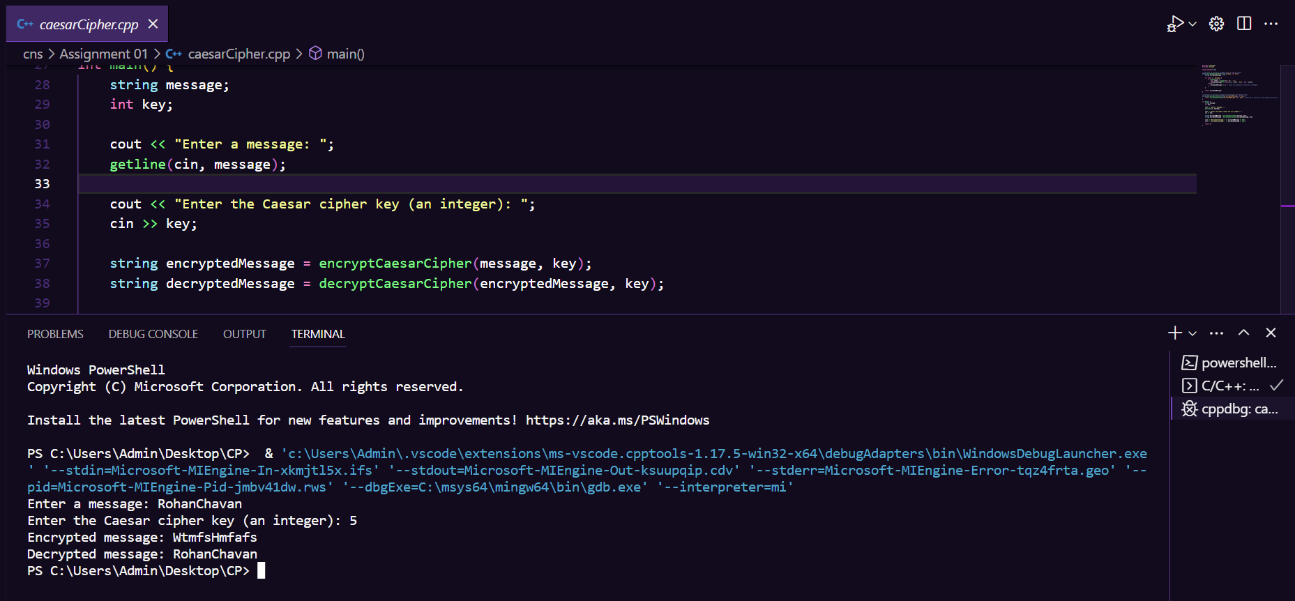**Result:**